National Changhua University of Education
Department of Business Administration
Drip Coffee
Professor
James Stanworth
Presented by Mogu Mogu
Irene Yeh S1163003
Judy Tsai S1163004
Chloe Lee S1163016
Andrea Hsieh S1163037
Joy Wang S1163043

Table of Contents
Introduction 3
1. The Features of Zhou Wu Drip Coffee 3
2. Target Country-Singapore 4
STP Analysis 4
1. Segmenting 4
2. Targeting 5
3. Positioning 6
Pricing 8
Promotion 9
1. Market 9
2. Online Store 9
3. Co-Branded 10
4. Hotel 11
Conclusion 11

Introduction

The Features of Zhou Wu Drip Coffee

Growing Environment
Zhuo Wu drip coffee cultivates the Orthocarpus purpurascens coffee variety, and grows it in the high-altitude mountain region of Alishan, which is at an elevation of 1,200 meters. Due to the large temperature difference in the mountains, the Orthocarpus purpurascens can absorb more energy through photosynthesis during the day and more effectively store this energy at night, converting it into the substance of the coffee fruits. So it may have higher acidity, as well as enhanced aroma and flavor.

Processing Method
As a roasting degree, Zhou Wu drip coffee offers both light and medium roast coffee beans for consumers to choose from, catering to a wider range of tastes. Light roast coffee beans have distinct floral and fruity aromas and a pronounced acidity, with a light taste that fully showcases the original flavors of the beans. On the other hand, medium roast coffee beans have a milder acidity and higher sweetness, providing a full and smooth taste.
In terms of grinding degree Zhuo Wu drip coffee grinds its coffee beans to a fine consistency, which increases the extraction surface area of the coffee grounds. This allows the coffee to reach a higher concentration in a short amount of time and extracts a diverse range of flavors, resulting in the richest aroma.
Zhuo Wu drip coffee's innovative treatment method, the "Wild Creek Washing Method," sets it apart. This technique involves fermenting green coffee beans in a high mountain creek, utilizing the cool, pristine spring water, approximately 10 degrees Celsius in temperature. Through the friction between the beans and the flowing water, the coffee beans are washed until they achieve a smooth and clean finish, ensuring a refined and high-quality product.

Packaging Design
The design of the drip coffee allows it to hang directly on the cup, requiring only hot water to start brewing. The operation is very simple, requiring minimal preparation and cleanup, making the process quicker and more convenient. The vacuum packaging of Zhuo Wu drip coffee effectively blocks out air, reduces oxidation, and preserves the freshness and flavor of the coffee. Additionally, vacuum packaging locks in the coffee's aroma, preventing it from dissipating, ensuring that each brew retains its rich fragrance.

Taste
The quality of Zhuo Wu drip coffee beans, along with their roasting level, grind size, and extraction method, makes Zhuo Wu drip coffee taste refreshing and smooth. Also, it offers a rich variety of flavors to cater to consumers with different preferences, including citrus, plums, tea, Asian plum, and a light floral scent. Additionally, Zhuo Wu drip coffee is a low-caffeine option that is gentler on the stomach, reducing the likelihood of acid reflux compared to high-caffeine coffee, and it may also less likely to affect sleep.

Target Country-Singapore
We believe that Singapore is the most suitable country to import our product.
Taiwan currently implements the Southbound Policy, which is mainly divided into four major aspects: "economic and trade collaboration", "talent exchange", " resource sharing", and "regional connectivity". The purpose is to share resources, talent and markets with ASEAN, South Asia, New Zealand and Australia and other countries while creating a new and mutually beneficial model of cooperation.
In addition, compared with South Asia, New Zealand and Australia, the culture of Southeast Asia is relatively similar to Taiwan. Among the countries in Southeast Asia, Singapore is a country with a fast pace of life and stable economic development. It has a financial and trade center and its people have certain spending power.
Therefore, we think drip coffee, the best symbol of refined taste and convenience, is very suitable for Singapore.

STP Analysis

Segmenting

Demographic Segmentation
There are two groups in demographic segmentations. Firstly, Singapore age structures can be divided into four ranges: infancy (under 14 years old), teenager (15 to 24 years old), prime (25 to 64 years old), and elderly (over 65 years old). Secondly, occupational segmentation classifies individuals based on their professions, encompassing sectors like retail, wholesale & sales industry, transportation & warehousing industry, information & communication, finance & insurance industry, construction industry, real estate, catering industry, luxury goods, arts, entertainment & leisure services.

Geographical Segmentation
In geographical segmentation, Singapore’s 28 districts can be divided into three regions: the Core Central Region (CCR), Rest of Central Region (RCR), and Outside Central Region (OCR). The CCR includes the traditional prime areas of Singapore, the Downtown Core, as well as Sentosa. This is where most high-end, luxury properties in Singapore. The RCR is regarded as the intermediate between the mass market condos in the OCR region and the high-value properties in the CCR. The OCR is about three-quarters the size of Singapore, and basically refers to areas where mass-market condos at the lower range of price points are located, including Executive Condominiums (ECs).

Behavior Segmentation
Behavioral segmentation of the coffee market in Singapore focuses on whether people buy and drink the coffee, as well as how often and how much they drink it. Customers can be categorized in terms of usage rates, for example, heavy, medium, light, and nonuser. Customers can also be segmented according to user status: potential users, nonusers, ex-users, regulars, first-timers, and users of competitors’ products. (Keegan, 2014, p. 226)
In addition, it can segment based on the shopping habits of Singaporeans, for example, café culture, grab-and-go convenience, home brewing, online purchases, supermarket, or specialty stores. It can also segment based on the brand loyalty, such as committed buyers, brand likers, satisfied buyers with switching costs, satisfied or habitual buyers, and switchers.

Targeting
Our target customers are aged between 25 to 64 years old and over 65 years old, who live and work in Singapore’s Core Central Region (CCR). They are professionals engaged in retail, transportation & warehousing industry, finance & insurance industry, luxury goods, and real estate sectors. These people appreciate high-quality, aromatic coffee and seek convenience. Our Zhou Wu drip coffee is designed to meet their refined preferences, offering an exceptional coffee experience for them.

Aged Between 25 to 64 Years Old and Over 65 Years Old
We choose Singaporean customers aged 25 to 64 as our target customers because this age group is the main source of labor in Singapore. In addition, we also targeted people over 65 years old. It is because according to the statistics, this age group is expected to become the second largest population group in Singapore in the future. Let’s take a look at the chart below.
Figure 1: Singapore’s population structure over the years
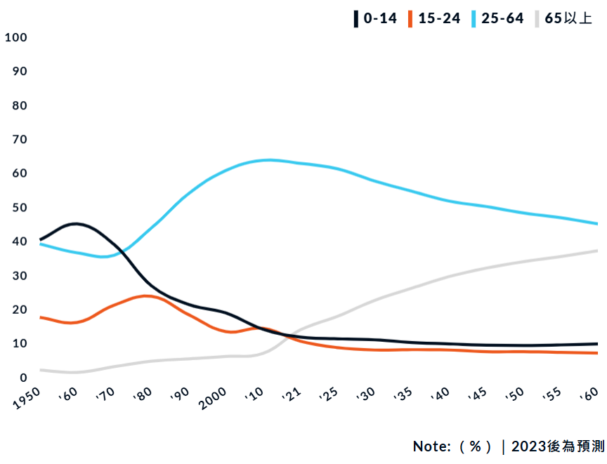
Source: Web page information

People Who Work in the Core Central Region
This place is a primer and prestigious region in Singapore. Most of famous financial institutions, high-end shopping malls, and luxury hotels are in this place.

People Who Are Engaged in Some Part of Industry in Singapore
We target people who are engaged in the retail industry, transportation and warehousing industry, finance and insurance industry, luxury goods industry, real estate industry, etc. as our target market customers. It is because these industries are the major industries in the Core Central Region of Singapore.

Positioning

Product Positioning
Because the specialty coffee market in Singapore has continued to grow in recent years. We want to use the high quality and uniqueness of Zhuo Wu drip coffee as a sales highlight. Positioning it in the mid-to-high-end coffee market, and try to compete with the well-known local specialty coffee brands like hook coffee, Bacha coffee, etc. Keep up with other brands and make changes to adapt to the market, but at the same time we will still maintain the unique Taiwanese flavor and service, so as to attract consumers who value quality and unique flavor.

Competitors Analysis& Positioning Map
After market segmentation, we chose the Singapore specialty coffee market as the target market and selected the following specialty coffee brands that sell drip coffee bags for competitor comparison to facilitate product positioning practice, and so on do the pricing decisions.
The selected brands will be priced based on the drip coffee products sold through its online channel (its official website) as the price error (in Singapore dollars) caused by commissions from other online and offline platforms will be less.
Competitors of these coffee brands all position their brands as specialty coffee, so compared to comparing the entire coffee market, the quality is not much different. Because they all focus on high quality, so the main obvious difference is their pricing, which we will analyze. The following is our analysis table and positioning map.
Table 1: Competitors Price Analysis Table
Brand Names | Bags/box | Price | Price/bags
Hook Coffee | 10bags/box | S$20 | S$2
Common Man Coffee Roasters | 6bags/box | TWD$465(S$19.39) | S$3.23
The Coffee Academics | 5bags/box | HK$78(S$13.42) | S$2.684
PPP Coffee | 9bags/box | US$30(S$40.32) | S$4.48
Bacha | 12bags/box | US$25(S$33.6) | S$2.8
Starbucks | 4bags/box | US$7.67(S$10.31) | S$2.5775
Sources: Official websites of each brand
Below is our positioning map. We believe our drip coffee will be able to achieve high quality and reasonably high price, and have the ability to stand out from our competitors.
Figure 2: Positioning map
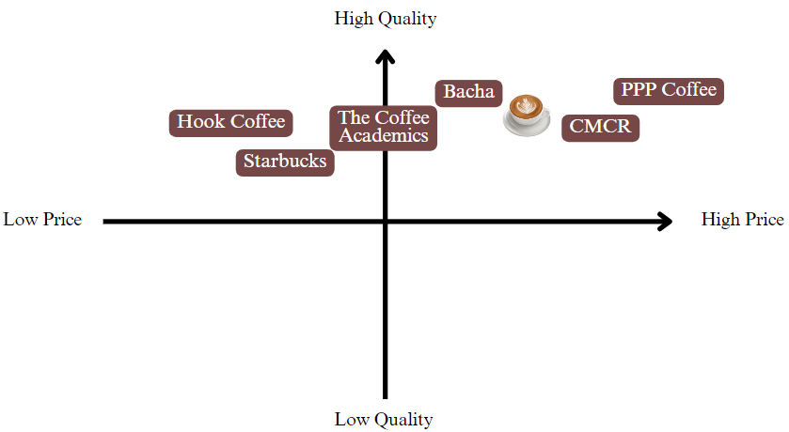
Source: Our own analysis chart

How to Adapt to The Singapore Specialty Coffee Market?
The way we choose to adapt to the market is glocalization. Singaporeans prefer to drink one kind of coffee. They call it "Kopi Gu You," which means "butter coffee." In order to adapt to the coffee drinking habits of Singaporeans. Therefore, we decided to offer sugar and butter in drip coffee bags so that consumers can take the butter and sugar home to use or cook themselves. Also to differentiate our service from other competitors through global localization.

Pricing
We converted the Taiwanese pricing of Zhuo Wu drip coffee into Singapore dollars and compared it with existing pricing in Singapore and our competitors. Our analysis included the following brands: Hook Coffee (S$2 per bag), Common Man Coffee Roasters (S$3.23 per bag), The Coffee Academics (S$2.684 per bag), PPP Coffee (S$4.48 per bag), Bacha (S$2.8 per bag), and Starbucks (S$2.5775 per bag).
In addition, taking into account the coffee drinking habits of Singaporeans, we decided to provide sugar and butter in the drip coffee bags. Therefore, adding the cost of sugar and butter, we finally price our drip coffee at S$2.9 to S$3 per bag.
This pricing strategy ensures that our product is competitively positioned while reflecting the added value and quality we offer to our customers.

Promotion
To promote Zhou-Wu drip coffee in Singapore, we will utilize a comprehensive strategy that includes both physical and digital channels, ensuring maximum reach and engagement.

Market
We choose the top 3 online most frequently used grocery stores & supermarkets in Singapore that are ranked in no particular order to sell our products. The market we want to sell our products are as follows:

NTUC FairPrice
It is the largest supermarket chain in Singapore, offering a wide range of daily necessities, food, and fresh produce. It has numerous branches nationwide, providing convenient shopping for residents.

Giant
It is another popular supermarket chain known for its affordable prices on various products. Its branches are spread across the island, ranging from small community stores to large hypermarkets.

Cold Storage
It specializes in imported goods and high-quality fresh food, making it a favorite among mid-to-high-end consumers. Its branches are typically located in more upscale malls and areas.

Online Store
By setting up official stores on the online shopping platforms that Singaporeans are more commonly used for. The platform we want to set up our stores are as follows:

Shopee
Shopee is one of the leading e-commerce platforms in Singapore, offering a vast selection of products ranging from electronics and fashion to groceries and household items. It is known for its user-friendly interface and frequent promotional deals​.

Lazada
Lazada is another major online shopping site in Singapore, providing a wide variety of products. It features regular sales events and has a strong logistics network, ensuring fast delivery services​.

Carousell
This home-grown platform allows users to buy and sell both new and secondhand goods. Carousell is popular for its variety of products, including electronics, fashion, and even cars. It also supports services like IT support and home repair​.

Co-Branded
We are primarily seeking to collaborate with local dessert and tea brands that pursue a high-end aesthetic. This partnership will not only enhance cultural integration but also maintain our shared commitment to quality and excellence. What is more, we hope to launch limited edition gift boxes that include drip coffee and co-branded products such as chocolates, tea, baked goods, etc., with special promotions during holidays and festive seasons. The brands we want to collaborate are as follows:

Janice Wang
Janice Wong is a renowned pastry chef and chocolatier from Singapore, her chocolates known for their unique flavors and artistic presentation. Using high-quality ingredients and inspired by diverse culinary traditions, her chocolates are a delightful fusion of taste and art, making them a popular choice for those seeking premium and creative confections in Singapore.

Awfully chocolate
Awfully Chocolate is a renowned Singaporean brand specializing in premium chocolate desserts. It emphasizes high-quality ingredients and minimalist elegance, offering a luxurious chocolate experience that has garnered a loyal following both locally and internationally.

TWG Tea
TWG Tea is a luxury tea brand known for its high-quality tea blends and exquisite packaging. The brand offers an extensive collection of teas from around the world, including rare and exclusive varieties. TWG Tea also operates elegant tea salons and boutiques globally, providing a refined tea-drinking experience.

Hotel
Additionally, we are looking to collaborate with well-known local hotels to offer co-branded in-room coffee sets or to establish brand displays and tasting areas within the hotels to enhance the guest experience. Moreover, we aim to promote Taiwanese drip coffee brands to international travelers to expand their recognition. The hotel we want to collaborate is as follow:

The Warehouse Hotel
The Warehouse Hotel is a stylish boutique hotel located in Singapore's Robertson Quay. Housed in a beautifully restored heritage building, it offers a blend of historical charm and modern luxury. The hotel features elegant rooms and suites, a rooftop pool, and a trendy restaurant and bar. It is known for its unique architecture and excellent service, making it a popular choice for both leisure and business travelers.

Conclusion
Coffee has long been a part of Singapore's culture, and today it plays a significant role in the daily lives of Singaporeans. We believe that our exquisite coffee, with its moderate to high pricing, unique aroma, and comprehensive service, is well-suited for the mid-to-high-end market in Singapore. Our product is priced between S$2.9 and S$3 per bag, depending on the cost variations of sugar and butter. To promote our coffee, we are focusing on both physical and online markets in Singapore. Additionally, we aim to collaborate with other brands to expand our reach. Ultimately, our goal is to convey the value of our brand to our target customers, emphasizing the importance of the small details in our products. We strive to create a premium coffee experience that resonates with consumers and highlights the meticulous care that goes into every cup of our coffee.

https://greenbox.tw/Blog/BlogPostNew/6895/
https://www.cometrue-coffee.com/blog/grindsizeflavor
https://www.zhanlu.com.tw/%E6%B7%B1%E7%84%99%E5%92%96%E5%95%A1/
https://idrip.coffee/coffee/zhuowu-C087-F200102
https://reurl.cc/QRgWD0
https://www.cigna.com.hk/zh-hant/smarthealth/eat/decaffeinated-coffee-health-benefits
https://www.ey.gov.tw/Page/5A8A0CB5B41DA11E/c2ea8a21-7aca-416b-9937-ed9bfbd6fbe6
https://www.propertyguru.com.sg/property-guides/ccr-ocr-rcr-region-singapore-ura-map-21045
https://buycondo.sg/ccr-rcr-ocr/
Keegan, W. J. (2014). Global Marketing Management. England: Pearson.
https://elementthree.com/blog/what-brand-loyalty-means-for-your-business-and-why-it-matters/
https://zh.oosga.com/demographics/sgp/
https://www.propertyguru.com.sg/property-guides/ccr-ocr-rcr-region-singapore-ura-map-21045
https://numberoneproperty.com/market-segment-in-singapore/
https://perfectdailygrind.com/2021/08/understanding-the-singaporean-coffee-market/
https://hookcoffee.com.sg/catalogue/category/hook-bags_10/
https://commonmancoffeeroasters.com/collections/coffee-drip-bags
https://www.theacademicsgroup.com/collections/drip-bags
https://pppcoffee.com/collections/drip-bags
https://bachacoffee.com/packed-coffees-accessories/packed-coffees
https://www.starbucksathome.com/sg/products/origami
https://www.singaporeanmalaysianrecipes.com/butter-coffee-kopi-gu-you/
https://morebetter.sg/best-supermarket-grocery-stores-singapore/
https://thehoneycombers.com/singapore/local-international-supermarkets-in-singapore/
https://simibest.sg/11-best-online-shopping-platforms-in-singapore-2024/
https://morebetter.sg/best-online-shopping-platform-sites-singapore/
https://janicewong.online/
https://shop.awfullychocolate.com/
https://twgtea.com/
https://www.thewarehousehotel.com/

